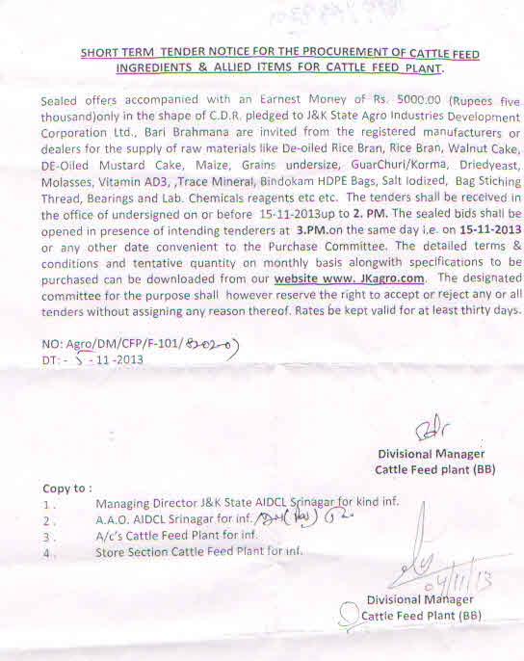

PART ‐A

 |  | Estimated Qty.
.No. | Item | required | Delivery | Payment terms | Remarks
 |  | on monthly basis
 |  |  | within 2‐3
1 | DORB | 3000‐4000 Qtls Appr. | weeks | Within 15 to 20 days | Procurement ca be made
 |  |  |  | after receipt of
 |  |  |  | material | even on seasonal basis
 |  |  |  | and satisfactory testing
 |  |  |  | thereof
2 | Rice Bran | 1000‐1200 Qtls | do | do | do
3 | Mustard De‐Oiled Cake | 1200‐1500 Qtls | do | do | do
4 | Walnut Cake | 200‐300 Qtls | do | do | do
5 | Molasses | 700‐800 Qtls | do | do | do
6 | Maize/Grains(under size) | 200‐300 Qtls | do | do | do
7 | Sun flower Ext. Cake/ | 200‐300 Qtls | do | do | do
 | Ground Nut Ext Cake
8 | Guar Churi /Korma | 100‐200 Qtls | do | do | do

PART ‐B

 |  | Estimated Qty.
.No. | Item | required | Delivery | Payment terms | Remarks
 |  | on monthly basis
1 | Lime Stone Powder/ | 100‐200 Qtls Approx | do | do | Procurement ca be considered
 | Calcite Powder /DCP |  |  |  | for annual rate contract
2 | Mineral Mixture | 100‐150 Qtls | do | do | do
3 | Trace Mineral | 5‐10 Qtls
4 | Optigen | 30‐40 Qtls | do | do | do
5 | Bindokam | 15‐20 Qtls | do | do | do
6 | Vitamn AD3 | 7‐8 Kgs | do | do | do
7 | Salt | 150‐200 Qtls | do | do | do
8 | HDPE Bags | 20000 Bags Approx | do | do | do
9 | Bag Stiching Thread | 30‐40 Cones | do | do | do

Divisional Manager

Cattle Feed Plant (BB)

NIT No. Agro/DM/CFP/F‐101/8202-07

Dated:‐05-11-2013

